Allocation Panel Sign Up Sheet
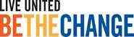
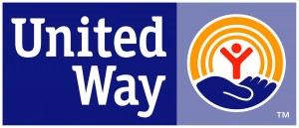

United Way South Sarasota County

First and last name:
Email address best to receive allocation materials at-
Employer:
Title:
Work address:
* Work phone:
Home Address:
Home phone:
Do you belong to any non-profit boards?
Do you volunteer at a local non-profit agency?
Panel Members Requirements: Local resident willing to objectively read, review and score 5 to 6 agency grant applications in April with availability to dedicate approx. 6 – 8 hours in May and June for interviews and site visits.
Thank you for caring about South Sarasota County
UWSSC 2015-2016 Funded agencies:
Big Brother, Big Sisters; Boys & Girls Club ; Center of Hope; Child Protection Center; Children First; Community for the Deaf & Hard of Hearing; Good Samaritan Pharmacy; Englewood YMCA; Epilepsy Services; Family Network on Disabilities; The Florida center; Girl Scouts of the Suncoast; Gulf Coast Legal; Jewish Family Services; Literacy Volunteer’s; Loveland Center; Lutheran Services; Meal on Wheels North Port; Mental Health Communities; North Port YMCA; SPARCC; Salvation Army; Skye Family YMCA: Senior Friendship Centers; Teen Court; United Way 2.1.1.; Venice Area Mobile Meals; Englewood Community Care Clinic
New agency candidates being considered for 2016-2017 UWSSC funding: Forty Carrots’ Family Centers , Community Youth Development (CYD) and Family Promise

157 Havana Road, Venice, FL. 34292 * 941-484-4811
Email back to : maryann@uwssc.com

